Autobusu kustības saraksts pilsētas nozīmes maršrutā
Jauntukums - Veļķi (sestdienās)
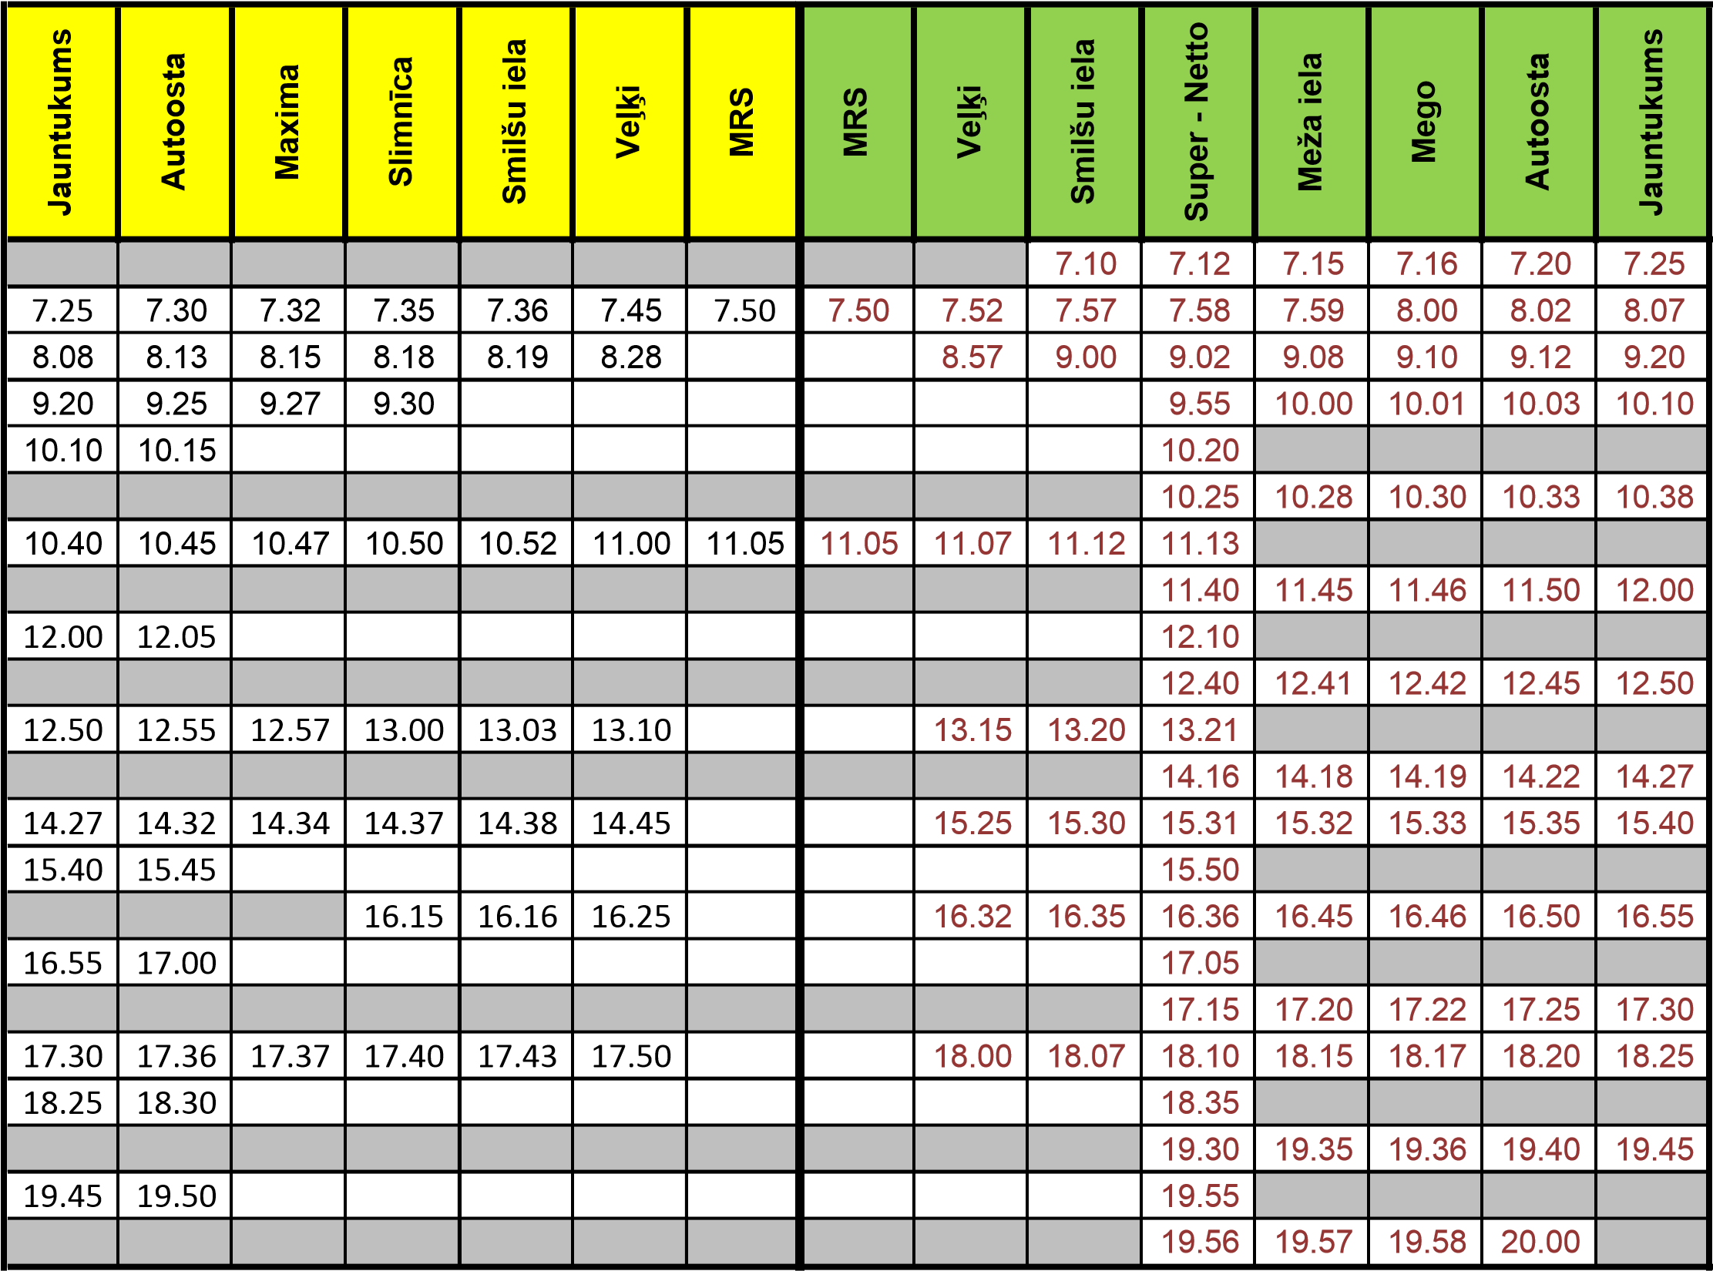
Autobusu kustības saraksts pilsētas nozīmes maršrutā
Durbe - Tume (sestdienās)
Durbe | Autoosta | Maxima | Super - Netto | Talsu iela | Šekumkrogs | LLT | Tume | Tume | LLT | Šekumkrogs | Smilšu iela | Meža iela | Mego | Autoosta | Durbe
 |  |  |  |  |  |  |  |  |  |  | 7.02 | 7.06 | 7.08 | 7.10 | 7.15
7.15 | 7.20 |  | 7.22 | 7.25 | 7.28 | 7.33 | 7.40 | 7.40 | 7.47 | 7.52 |  | 7.57 | 7.58 | 8.00 | 8.08
8.08 | 8.13 |  | 8.16 | 8.18 | 8.21 | 8.26 |  |  | 9.02 | 9.07 |  | 9.12 | 9.13 | 9.15 | 9.20
9.20 | 9.25 | 9.27 |  | 9.30 | 9.33 | 9.38 | 9.45 | 9.45 | 9.52 | 9.57 |  | 10.02 | 10.03 | 10.05 | 10.10
10.20 | 10.25 |  | 10.28 | 10.30 | 10.40 | 10.45 |  |  | 10.55 | 11.00 |  | 11.05 | 11.06 | 11.08 | 11.13
11.13 | 11.18 | 11.20 |  | 11.22 | 11.25 | 11.30 | 11.37 | 11.45 | 11.52 | 11.57 |  | 12.02 | 12.03 | 12.05
 |  |  |  |  |  |  |  |  |  |  |  |  |  | 14.21 | 14.26
14.26 | 14.31 |  | 14.35
 |  |  | 15.30 |  |  |  |  |  |  |  |  | 15.32 | 15.33 | 15.35 | 15.40
15.40 | 15.45 |  | 15.48 | 15.50 | 15.53 | 15.58 | 16.05 | 17.00 | 17.07 | 17.12 |  | 17.17 | 17.18 | 17.20 | 17.25
17.25 | 17.30 | 17.32 |  | 17.34 | 17.37 | 17.42 |  |  | 18.05 | 18.15 |  | 18.20 | 18.21 | 18.23

